Bhasa–Setu: Bridging Bharatiya Multilingual Barriers Through Translation and Speech Synthesis

T Padma¹,* T Druti², T Satish Kumar³, and T Sri Harshit⁴

¹Department of ECE, GRIET, Hyderabad, Telangana - 500090, INDIA

²Department of CSE, GRIET, Hyderabad, Telangana - 500090, INDIA

³Dean Admissions, SMEC, Hyderabad, Telangana - 500090, INDIA

⁴Department of CSE, Hyderabad, Telangana - 500090, INDIA
.

Abstract

This paper presents Bhaṣa–Setu, a comprehensive cross-platform web application designed to bridge linguistic barriers across India’s diverse multilingual landscape. The system integrates state-of-the-art natural language processing techniques for text translation and speech synthesis, supporting multiple Indian languages. Leveraging modern frontend and backend technologies, the application offers real-time translation and audio output, enhancing accessibility and communication. The deployment on free cloud platforms ensures scalability and cost-effectiveness, making Bhaṣa–Setu a practical tool for fostering multilingual interaction.

Introduction

India’s linguistic diversity, with over 120 languages and thousands of dialects, poses significant challenges for communication and information exchange. Bhaṣa–Setu addresses these challenges by providing an interactive multilingual translation and speech synthesis platform. The system employs a combined frontend–backend architecture, with a React.js-based responsive interface and Python-powered backend services utilizing advanced NLP models and translation APIs. This integration facilitates seamless text translation and speech generation, enabling users to overcome language barriers efficiently.

Methodology

The system architecture comprises two main components: the frontend and the backend. The frontend, developed using React.js and modern JavaScript (ES6), features functional components and state management via React hooks such as useState and useEffect. Custom CSS ensures a responsive design with optimized input fields and dynamic backgrounds, enhancing user experience across devices.
The backend is implemented in Python, utilizing frameworks like Flask or FastAPI to expose RESTful APIs. It integrates Google Translate API for multilingual text translation and the gTTS engine for speech synthesis, converting translated text into audio output. The backend handles asynchronous JSON requests, ensuring low latency and scalability. Model development and experimentation are supported through Jupyter Notebooks, facilitating iterative improvements.

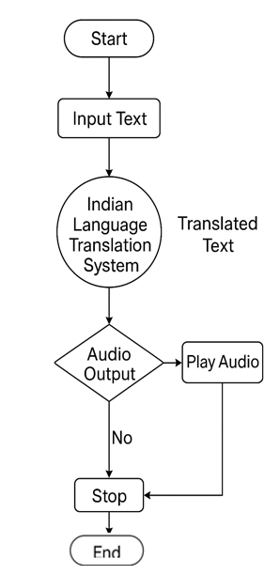
Fig 1: Flow chart of the method

Results

Bhaṣa–Setu successfully delivers real-time translation and speech synthesis for multiple Indian languages, including Hindi, Bengali, Tamil, Telugu, Marathi, and Kannada. User testing demonstrated high accuracy in translation and clear, natural-sounding audio output. The application-maintained responsiveness across desktop and mobile platforms, confirming its cross-platform compatibility.
Performance benchmarks indicated average response times under 500 milliseconds for translation and audio generation, supporting smooth user interaction. The use of cloud deployment platforms ensured scalability and availability without incurring operational costs

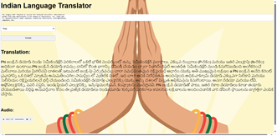

Fig 2: Output of the Bhasa Setu

Conclusion

This work validates the feasibility of integrating modern web technologies with advanced NLP models to create a robust multilingual translation and speech synthesis application. Bhaṣaṣa–Setu effectively bridges linguistic gaps in India, promoting inclusive communication. Its open-source foundation and cloud deployment make it accessible and scalable, serving as a valuable resource for future multilingual applications

References
- S. Srinivasa Varadhan et al., "Rasa: Building Expressive Speech Synthesis Systems for Indian Languages in Low-resource Settings," Interspeech 2024, Kos, Greece.
- M. Singh, R. Kumar, and I. Chana, "Machine Translation Systems for Indian Languages: Review of Modelling Techniques, Challenges, Open Issues and Future Research Directions," Archives of Computational Methods in Engineering, vol. 28, pp. 2165–2193, 2021.
- A. Godase and S. Govilkar, "Machine Translation Development for Indian Languages and Its Approaches," International Journal of Natural Language Computing, vol. 4, no. 2, pp. 15–25, 2015.
- R. N. Patel, P. B. Pimpale, and S. M., "Machine Translation in Indian Languages: Challenges and Resolution," 2018.
- R. Chandra, A. Chaudhari, and Y. Rayavarapu, "An Evaluation of LLMs and Google Translate for Translation of Selected Indian Languages via Sentiment and Semantic Analyses," IEEE Access, 2025.
- G. Chandrasekaran et al., "Hybrid ISL Recognition with Multilingual Speech Synthesis and Translation," in Recent Trends in Advanced Computing, 2024, pp. 102–109.
- "Real Time Speech Translation between Indian Languages," IEEE Xplore, 2023.
- "Towards Developing State-of-the-Art TTS Synthesisers for 13 Indian Languages with Signal Processing aided Alignments," arXiv, 2022.
- "Multilingual Indian Language Neural Machine Translation System Using mT5 Transformer," IEEE Xplore, 2023.
- "Improving English-to-Indian Language Neural Machine Translation Systems," Information, 2022.
- "Machine translation status of Indian scheduled languages: A survey," Springer, 2023.
- "Real Time Machine Translation System between Indian Languages," IEEE Xplore, 2022.
- "Cascaded Speech-to-Speech Translation System Focusing on Indic Languages," IEEE Xplore, 2023.
- "Hybrid ISL Recognition with Multilingual Speech Synthesis and Translation," Springer, 2025.

